1st Quarter Project - Trip Planning
50 Pts.

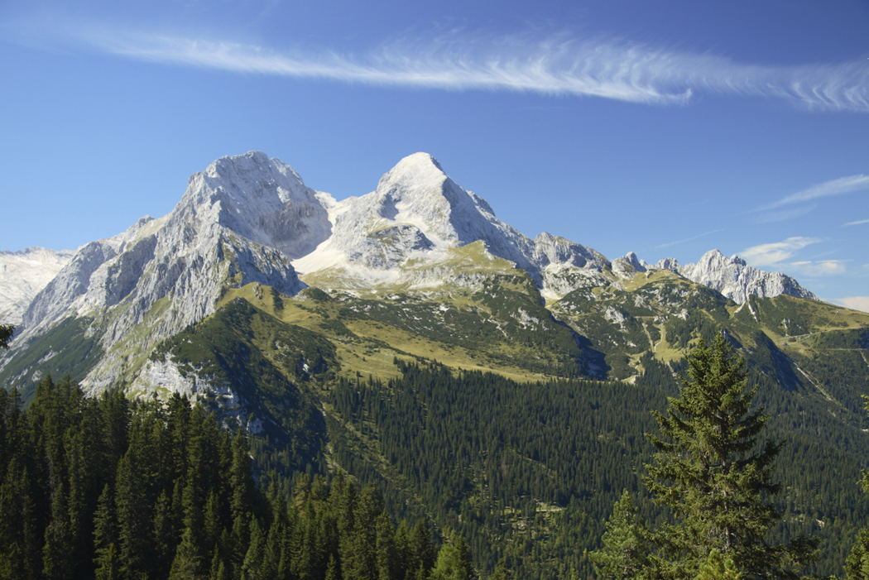

Overview:
- With a partner, you will devise a trip that you could take and plan EVERY aspect of that trip. From food to gas, from bait to equipment, nothing can be overlooked. It can be as simple as 4 days in the BWCA or as complex as a two week backpacking trip to Alaska. Choose a trip that you and your partner would enjoy in the hopes that some day you may fulfill that dream.

Requirements
- Your trip must be at least 4 days and 3 nights, but can be longer.
- Your destination must at least 2 hours from St Cloud.
- Your trip must include a daily plan. Your plan doesn’t need to be broken down hour by hour, but should give an idea of where you plan to be each day.
  - For instance, if you plan a trip to the BWCA, you must include a float plan
    - (A float plan is a list of where you plan to be on certain days. For example, on Monday, we plan to get to Lake X. By Tuesday, we plan to travel through Lake Y to Lake Z. Etc.)
- You must include a packing list of clothes, equipment, menu, shopping list, expected gas usage, and any other items you may need or costs you will incur.
  - For example, permits or licenses needed.
  - You will need to total your costs for the trip.
- You should include any maps that you may need.
- You will also make a presentation to the class of an overview of the trip. You can use power point if you would like, but you don’t have to. Project will be due after break.
- You will get time in the computer lab.

