Tech High School
Phy Ed Packet

Name:_________________

Teacher:________________

Class Day/Period:__________

Reflective journals – Date_________
Question:_____________________________________________________________________________
Response:_____________________________________________________________________________
_____________________________________________________________________________________
_____________________________________________________________________________________
_____________________________________________________________________________________
_____________________________________________________________________________________
_____________________________________________________________________________________
_____________________________________________________________________________________
_____________________________________________________________________________________
_____________________________________________________________________________________
_____________________________________________________________________________________

Reflective journals – Date_________
Question:_____________________________________________________________________________
Response:_____________________________________________________________________________
_____________________________________________________________________________________
_____________________________________________________________________________________
_____________________________________________________________________________________
_____________________________________________________________________________________
_____________________________________________________________________________________
_____________________________________________________________________________________
_____________________________________________________________________________________
_____________________________________________________________________________________
_____________________________________________________________________________________
Reflective journals – Date_________
Question:_____________________________________________________________________________
Response:_____________________________________________________________________________
_____________________________________________________________________________________
_____________________________________________________________________________________
_____________________________________________________________________________________
_____________________________________________________________________________________
_____________________________________________________________________________________
_____________________________________________________________________________________
_____________________________________________________________________________________
_____________________________________________________________________________________
_____________________________________________________________________________________

Reflective journals – Date_________
Question:_____________________________________________________________________________
Response:_____________________________________________________________________________
_____________________________________________________________________________________
_____________________________________________________________________________________
_____________________________________________________________________________________
_____________________________________________________________________________________
_____________________________________________________________________________________
_____________________________________________________________________________________
_____________________________________________________________________________________
_____________________________________________________________________________________
_____________________________________________________________________________________
Major Body Muscles
(Fill in the blank)
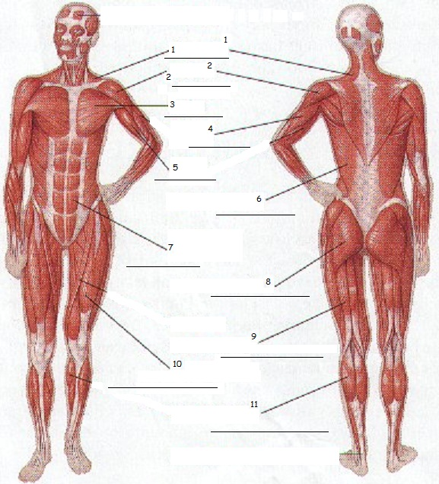
Abdominals Biceps Deltoid
Gastrocnemius (Calf) Gluteus Maximus Hamstring
Latissimus Dorsi Pectorals Quadriceps
Trapezius Triceps
Muscular Strength

1. In your own words, define muscular strength…

2. Give an example of an activity that will increase muscular strength…

3. In general, in order to build muscle strength, you would lift __________(heavy or light) weights _____________(a few or many) times.
Muscular Endurance
1. In your own words, define muscular endurance…

2. Give an example of an activity that will increase muscular endurance…

3. In general, in order to build muscle endurance, you would lift __________(heavy or light) weights _____________(a few or many) times.
Flexibility
1. In your own words, define flexibility…

2. Why is it important to be flexible?
-
-
-
-
3. When should you stretch?
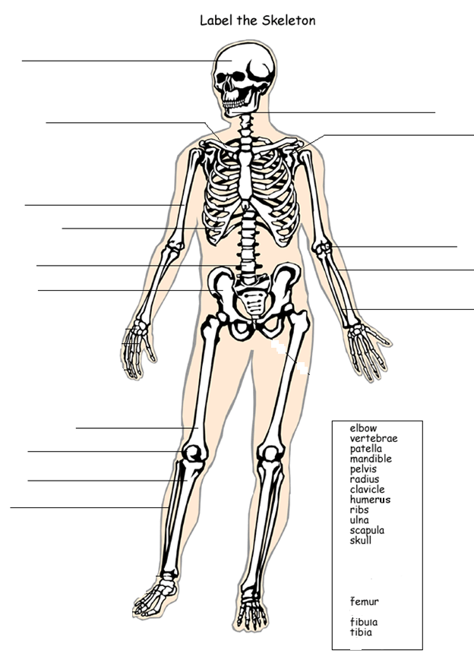

Name : ____________________ Date: ______________ Class Period:______

FITT Principle

FITT is an acronym used to describe the frequency, intensity, time and type of activity you need to participate in for that activity to produce benefits.

Frequency: How often you do physical activity. Frequency is the number of days per week that you participate in the activity (3-6 days a week).
Intensity: How hard you perform physical activities. The intensity must be greater than that required for normal daily activities (moderate to vigorous, Target Heart Rate Zone).
Time: How long you do physical activity. The activity must be done for an effective amount of time for benefits to result (30 – 60 minutes).
Type: What kind of activity you are performing (jogging, aerobics, swimming, basketball, biking).

- Indicate which of the following is an example of frequency (F), of intensity (I), and of time (T):

Walk within target heart rate zone _______________
Walk five days a week ______________
Walk for 45 minutes each day _____________

- Design an exercise programs. Make sure that both programs adhere to the FITT Principle.

Scenario 1: Marcia is a 15 year old ninth grader who is 5’6” tall and weighs 150 lbs. with 28% body fat. In September, she was timed in the mile at 11:56. Marcia wants to improve her time to 10:03. How can she meet this goal?

F –
I –
T –
T –

Scenario 2: Mike is a 16 year old 10 grader who is 5’11” tall and weighs 160 lbs. with 9% body fat. His goal is to make the varsity basketball team. How can he meet this goal?

F –
I –
T –
T –

Goal Setting

You can attain most any goal you set when you plan your steps wisely and establish a time frame that allows you to carry out those steps. Goals that may have seemed far away and out of reach eventually move closer and become attainable, not because your goals shrink, but because you grow and expand to match them. When you list your goals you build your self-image. You see yourself as worthy of these goals, and develop the traits and personality that allow you to possess them.

Creating SMART Goals.
(S)pecific - Answers the six “w" questions.
*Who: Who is involved? *What: What do I want to accomplish? *Where: Identify a location. *When: Establish a time frame. *Which: Identify requirements and constraints. *Why: Specific reasons, purpose or benefits of accomplishing the goal
(M)easurable - To determine if your goal is measurable, ask questions such as......How much?
How many? How will I know when it is accomplished?
(A)ttainable/(A)chievable - When you identify goals that are most important to you, you begin
to figure out ways you can make them come true. You develop the attitudes, abilities,
skills, and financial capacity to reach them.
(R)elevant/ (R)esults based - To be realistic, a goal must represent an objective toward which
you are both willing and able to work.)
(T)ime Bound / (T)ime Frame- A goal must have a target date. A deadline too far in the future
is too easily put off. A goal that's set too close is not only unrealistic, it's discouraging.

Sample:
1. What is my goal?
Lose 10 pounds

2. SMART
Specific – What do I want to accomplish? Fit into my skinny jeans
Measurable – How will I measure it? My jeans will zip up all the way
Achievable – Is it achievable by me now? yes
Relevant – Is it relevant to my life? yes
Time Bound – By what dates will I achieve it? By winter break

3. What Resources do I need to organize?
Walking shoes, motivational magazines, walking buddy

4. What do I need to schedule?
Walk 3 times a week for 30 minutes, ride bike 2 times a week for 45 minutes

5. What evidence will you submit to show where you are?
Weigh self in person, or take pic of scale, jeans fit halfway

Sources: Paul J. Meyer's "Attitude Is Everything." www.getoraganizedwizard.com

SMART Goal

- What is my goal?

- SMART
Specific – What do I want to accomplish?

Measurable – How will I measure it?

Achievable – Is it achievable by me now? How?

Relevant – Is it relevant to my life? How?

Time Bound – By what dates will I achieve it?

- What Resources do I need to organize?

- What do I need to schedule?

- What evidence will you submit to show where you are?

Heart Health

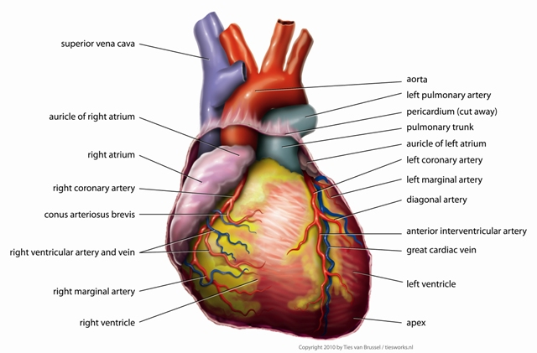

1) Where are the two best places to check your pulse?

2) Why shouldn’t I use my thumb to check my pulse?

3) When you have a diet high in saturate fat and you exercise very little, it leads to heart disease. This disease is a hardening or clogging of which arteries? This disease can lead to what?

4) The resting heart rate of a physically fit person will be _____________ (higher or lower) than that of an unfit person.

5) What is your resting heart rate? _________________ beats per minute

6) Finding your maximum heart rate…
220 – your age = approximate max heart rate (MHR)
220 - _______ = ________MHR

Fat Burning Target Zone – Approx. 60% of Max.
MHR x 60% = Lower target heart rate
_____ x .60 = _________

Cardiovascular Improvement Target Zone – Approx. 80% of Max
MHR x 80% = Higher target heart rate
_____ x .80 = _________

 | Your Score | Your Score | Presidential National | Presidential National | Presidential National | Presidential National
Test | Fall Test | Spring Test | Female Level (Above Ave.) | Female Level (Average) | Male Level (Above Ave.) | Male Level (Average)
Timed Mile |  |  | 7:59 | 10:06 | 6:26 | 7:44
Sit-Ups |  |  | 47 | 37 | 56 | 45
Flexed Arm Hang |  |  | 10 | 9 | 21 | 20
Shuttle Run |  |  | 10.1 | 11.2 | 9.1 | 9.9
Sit & Reach |  |  | 40 | 33 | 36 | 28
Pacer |  |  | 80 | 40 | 100 | 50
1. Identify your fitness strengths:
2. How can you maintain your fitness strengths throughout the school year?
3. Identify your fitness weakness:
4. How can you turn your weaknesses into strengths? (EX: If you get 8:00 in the mile, what steps do you take to drop your time?)
5. Are these fitness tests a true comparison to your overall health? (do your scores live up to who you are physically?)
6. What are the benefits of living a healthy lifestyle after high school?

Heart Rate Monitors
Your heart rate monitor is a very valuable tool to continually monitor your own heart rate. It allows each individual to see what their heart rate is during exercise. While you can check your pulse by hand, HRM’s are much quicker and more accurate. Here’s how you use our HRM’s…
WWW Wet the transmitter (harder plastic strap)
Wear it (Make sure you have a heart rate and that it is recording data)
Wash it and return it when class is over

RED – RED – BLUE – BLUE
1. Begin with the time screen (Push the blue button until the time screen appears)
2. Press the RED BUTTON ONCE so the watch finds your heart rate. (If your HR comes up blank or reads “00”, try one of the three options below BEFORE seeing your teacher)
- If you are not getting your heart rate reading, try one of the three options.
- Get the transmitter a little more wet
- Tighten the elastic strap
- Reposition the transmitter over your heart.
3. When ready to begin your workout, press the RED BUTTON – Your screen will have a time counting up and will also say TZ at the top. The main time that is counting is your total workout time. TZ represents the amount of time in your workout that was spent in your target zone.
4. Work out and monitor your progress.
5. Press BLUE BUTTON ONCE to pause your workout.
6. Press BLUE BUTTON again to end your workout.
7. Return all items to their proper location.

